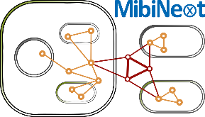
Thesis Advisory Committee Meeting
CRC 1535
Microbial Networking
- from organelles to cross-kingdom communities
- General Information
Type of Advisory Meeting:
☐ 1st year ☐ 2nd year ☐ 3rd year ☐ final meeting

Doctoral Researcher | Supervisor | Co-Supervisor/Mentor: | Postdoc
Name | Name | Name | Name

- Contents and Agreements Regarding Doctoral Research
Working Title of Doctoral Research Project/Thesis:

Current Status:
Please shortly report on the progress of the doctoral project during the past year (e.g. outcomes, achievements, progress, difficulties, milestones, deliverables, etc.).

Next Steps:
Please outline the next steps.

Publication strategy:
Please outline the next steps.

- Feedback on the presentation

Doctoral Candidate
Name:
Signature:..................................................................... Date: ..........................
Supervisor
Name:
Signature:..................................................................... Date: ..........................
Co-supervisor/Mentor
Name:
Signature:..................................................................... Date: ..........................
Postdoc
Name:
Signature:..................................................................... Date: ..........................

